‘There and Back Again’
Water of Leith Walk Challenge 26 miles, 15 miles or 11 miles
Sunday 23rd June 2019
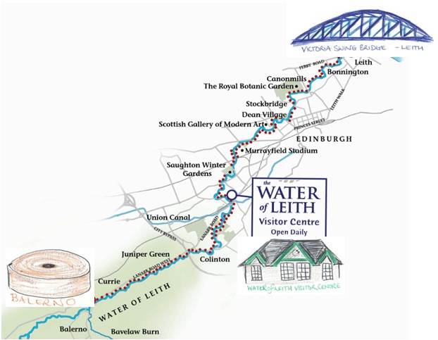
Explore Edinburgh’s hidden natural asset
& help raise funds to protect it

To register simply complete the form below and walk for free by collecting sponsorship yourself or using our event page on Just Giving
. If you prefer not to raise sponsorship you can register for just £15 each – Option B and C only. Joining instructions will be forwarded nearer the event

The Water of Leith Conservation Trust is a registered charity no SC000015. Our mission is: to conserve and enhance the Water of Leith as a haven for wildlife and an educational and recreational resource for all.

Option A: All the way ‘There & Back Again’ - 26 miles meeting at 9.00am at the Water of Leith Visitor Centre, walking to Leith and back, then heading up to Balerno and back to the centre (approx 9 hours)

Option B: Leith ‘There & Back Again’ - 15 miles meeting at 9.00am at the Water of Leith Visitor Centre, walking to Leith and back. (approx 5 hours)

Option C: Balerno ‘There & Back Again’ - 11 miles meeting at 2.00pm at the Water of Leith Visitor Centre, walking to Balerno and back. (approx 4 hours)
........................................................................................................................................................................
REGISTRATION FORM

OPTION A - I would like to register for the full 26 mile walk starting at 9.00am on 23rd June

OPTION B - I would like to register for the Leith ‘There & Back Again’ - 15 miles starting at 9.00am on 23rd June

OPTION C - I would like to register for the Balerno ‘There & Back Again’ - 11 miles starting at 2.00pm on 23rd June

Name:
Address:

Daytime Telephone:
Email:
Age:

Emergency Contact name:
Emergency Contact number:

Please tick one of the following statements:
I will be collecting sponsorship and therefore walk for free
I will not be collecting sponsorship & enclose a registration fee of £15
Option 2 is only available for OPTIONS B and C walk, Option A walkers must agree to collect sponsorship and join for free

Declaration: The organisers would like to remind you that you have entered this event at your own risk and that they are in no way liable for any injury before, during or after the event. Children must be accompanied by an adult at all times.
I have read and agree with the declaration above

Signature (typed is fine): Date:
Please return this form to: Water of Leith, 24 Lanark Road, Edinburgh. EH14 1TQ 0131 455 7367 or email admin@waterofleith.org.uk
SPONSORSHIP
You can use this form to collect sponsorship or create a Just Giving page visit https://www.justgiving.com/wolct/Donate/
Click on ‘Fundraise for us’ then ‘organised event’ select the ‘There & Back Again Walk’ and create and promote your own page. You can edit the photo, text and target. Any problems let us know & we can help

Name:

Address: Postcode:

I am walking the Water of Leith on Sun 23rd^{t} June to raise money for the Water of Leith Conservation Trust. My Challenge is to complete
A – 26 miles B – 15 miles C – 11 miles

NAME | ADDRESS with Postcode | Gift Aid * | AMOUNT
Total amount given
Gift Aid declaration - *We who have ticked the Gift Aid column on this form want The Water of Leith Conservation Trust to reclaim the tax on this donation. We each pay as much income and/or capital gains tax as The Trust will reclaim in the tax year, currently 25p for every £1 donated. Registered Charity Number SC000015

Returning your sponsorship money: Please make cheques payable to: Water of Leith Conservation Trust, and/or send cash with the completed form to: Water of Leith Visitor Centre,24 Lanark Road, Edinburgh, EH14 1TQ. Or call into the centre we are open 10.00 to 4.00 everyday.

